Torches in the Deep: How Marine Lives Illuminate the Abyss
By Samiha Subha Sooha
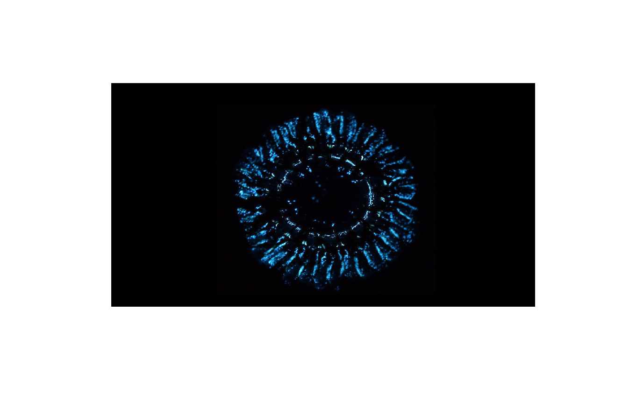
Atolla jelly lighting up the pitch-black ocean (Image credit: Steve Haddock/Monterey Bay Aquarium Research Institute)
Sparkling blue waves in the night are often seen near beaches. For centuries, the glowing waves were believed to be the work of Poseidon (God of the sea) or his nymphs by Greek sailors. Others considered them omens —a sign of sea monsters or spirits. Today, this mesmerizing phenomenon is known as a natural wonder called bioluminescence. And the stunning light show is a gift of tiny dinoflagellates that emit vibrant blue-green light.
Just beyond the twilight, the ocean looks like a dark, endless void. Characterized by increasing pressure, cold temperatures, and little food, the ocean is deeper than one can imagine. The deepest region of the sea, the Challenger Deep, is located within the Mariana Trench, at an approximate depth of 11,000 meters. It stretches farther below the surface than the highest mountain on Earth, Mount Everest, rising above it. The ocean encompasses a biome far larger than that of all the continents combined. However, sunlight, being the primary source of energy and light on Earth, can only penetrate up to about 1000 meters in the water column. As a result, the vast abyssal zone below remains devoid of sunlight. Yet, the lack of sunlight does not prevent life from flourishing in the deeper oceans.
The only sources of light are the life residing in the dark aphotic zone. These creatures have evolved to create light of their own, just like the fireflies on land.
This phenomenon, when living beings can naturally produce and emit light, is widely known as bioluminescence.
Light is produced as a result of a chemical reaction when luciferin (a light-emitting compound) oxidizes in the presence of the enzyme luciferase. The generic terms luciferin and luciferase originate from Lucifer, which is a Latin word that means ‘light bearer’. The molecular structures of these two compounds differ within species.
Although bioluminescence is a rare occurrence among terrestrial animals, it is a familiar trait in the ocean. A study conducted by Martini and Haddock showed that about 76% of marine organisms are bioluminescent. From single-celled phytoplankton on the surface to deep-sea fish, this phenomenon is found in diverse ranges of species. With advancing technologies, ocean observations have become much easier. According to Lee, when deep-water trawling became possible below 1200 feet in the 19th century, it was discovered that nearly all specimens exhibited a bioluminescent nature.
Marine organisms that glow in the deep include jellyfish, squids, fish, and crustaceans, as well as bacteria.

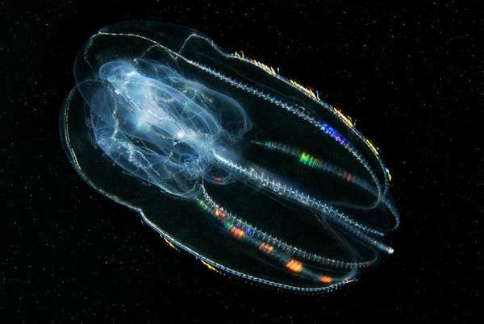
Comb jellies exhibit a rainbow-like display due to the refraction of light by cilia present in their body. (Image credit: William Browne, University of Miami)
In the deep sea, animals create a variety of colors.
Deep-sea shrimp, comb jelly (ctenophores), hatchetfish, and many other oceanic creatures emit blue light. The Atolla jellyfish produces intense blue light with occasional red flashes. The angler fish uses a blue-green lure to attract prey.
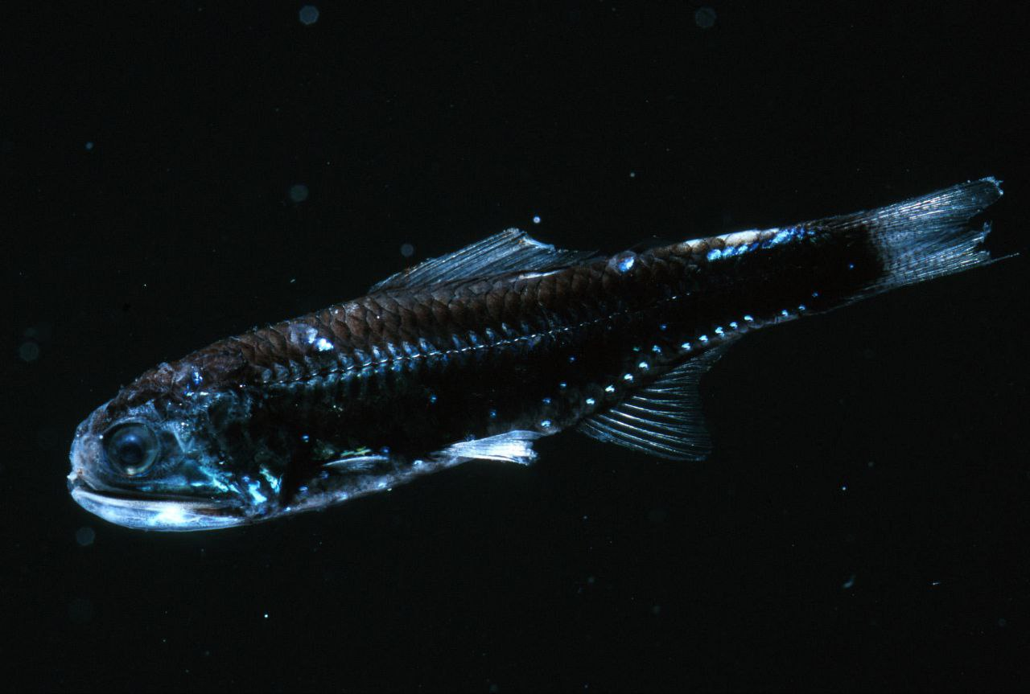
A lantern fish with photophores (Image credit: Steve Haddock/Monterey Bay Aquarium Research Institute)
Another abundant fish in the abyssal zone, known as the lantern fish, also emits blue light from photophores, or light-producing organs, located throughout its body.
Interestingly, the deep ocean dragonfish glows red. It is an unusual attribute that aids in camouflage and predation. Thus, most lights are blue and green since these wavelengths are less likely to be absorbed and can travel longer distances than red lights.
In the abyss, food shortage is a major problem with no photosynthesis. For the majority of animals, the primary food source is organic materials such as fecal matter and decaying body parts, falling from the surface waters known as ‘Marine Snow’. Others rely on predatory methods to obtain food. Bioluminescence is an effective tool in searching for food in remote habitats. In dark abyssal waters, some animals use light to briefly illuminate the surroundings and reveal the position of prey. Lights can also be used as lures to attract prey.
At the same time, it is also useful in order to escape predators. It enables organisms to detect potential dangers. A remarkable example can be seen in case of certain brittle stars that can detach glowing body parts and escape by misleading their attackers. Therefore, bioluminescence provides better protection and can help organisms to hide in the dark ocean. Additionally, bioluminescent species use their attractive lights to find mates. Some other marine animals use light signals to communicate with each other through warning flashes and group coordination. This ability of organisms to create light stands as a vital adaptation strategy in the deep ocean.
In addition to its many advantages, bioluminescence is a highly efficient reaction that produces very little heat. Hence, it is referred to as cold light. This makes it well-suited for deep-sea organisms where conservation of energy is very important.
Bioluminescence is a unique trait of nature, particularly essential in the case of abyssal animals. Despite being inhabitants of the deeper ocean, these are not immune to the impact of human activities. Deep-sea mining, extractive activities, pollution, and climate change have emerged as significant threats to the fragile ecosystems these bioluminescent species call home. As deep-sea explorations have increased over time, protecting these fragile ecosystems becomes crucial.
Marine life forms illuminate the dark realm, much like the stars in the night sky. In the dark abyss, where survival is an intense fight, bioluminescence is one of nature's greatest blessings.

References
Lee, J. (2008). Bioluminescence: the First 3000 Years (Review). Journal of Siberian Federal University. Biology, 1(3), 194–205. https://doi.org/10.17516/1997-1389-0264
Martini, S., & Haddock, S. H. D. (2017). Quantification of bioluminescence from the surface to the deep sea demonstrates its predominance as an ecological trait. Scientific Reports, 7(1), 45750. https://doi.org/10.1038/srep45750
Wilson, T. V. (2007). How bioluminescence works. HowStuffWorks. https://animals.howstuffworks.com/animal-facts/bioluminescence.htm
Laskow, S. (2016). The Strange Phenomenon Sailors Called "The Burning of the Sea". https://www.mentalfloss.com/article/57252/strange-phenomenon-sailors-called-burning-sea

